Unit 02 Problem Set Submission Form

# Overview

|  |  |
| --- | --- |
| Your Name | Hrishikesh Telang |
| Your SU Email | hmtelang@syr.edu |

# Instructions

Put your name and SU email at the top. Answer these questions all from the lab. When asked to include screenshots, please follow the screen shot guidelines from the first lab.

Remember as you complete the problem sets it is not only about getting it right / correct. We will discuss the answers in class so it’s important to articulate anything you would like to contribute to the discussion in your answer:

* If you feel the question is vague, include any assumptions you've made.
* If you feel the answer requires interpretation or justification provide it.
* If you do not know the answer to the question, articulate what you tried and how you are stuck.

This how you receive credit for answering questions which might not be correct.

# Questions

1. Does a table consist of data or metadata? Explain.  
   **A table consists of data and metadata both. This is because,**
2. Describe what happens when you attempt to insert 200 characters into a column with a data type of varchar (50)?  
   **The DBMS will essentially truncate the number of characters to a varchar length of 50 during table creation.**
3. How do we enforce entity integrity over a table which uses a surrogate primary key?  
   **We can enforce entity integrity by using a composite primary key that includes the surrogate key and either a natural key such as an SSN or a VIN, or a secondary key that could provide some unique identification for example: a Department ID or an Employee ID. We could also employ a foreign key reference of the keys mentioned earlier as a primary key of the referencing table to ensure referential integrity in the database.**
4. Provide a screenshot of your completed **customers** table include columns, indexes and foreign keys.   
   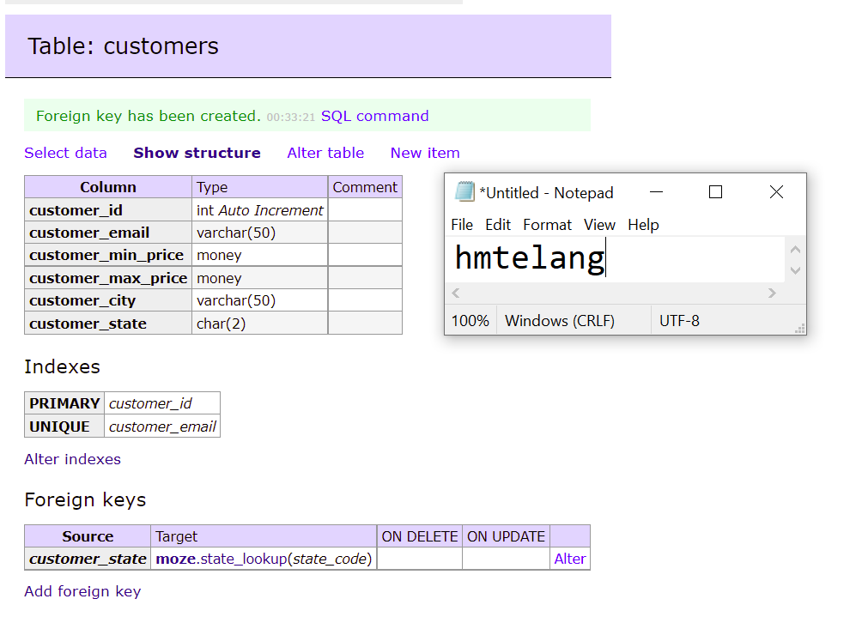
5. Implement the **contractors** table as defined in the overview section. Include columns, indexes (pk/unique) and foreign keys. Provide a screenshot of the table structure screen in Adminer and include the columns, indexes, and foreign keys sections.   
   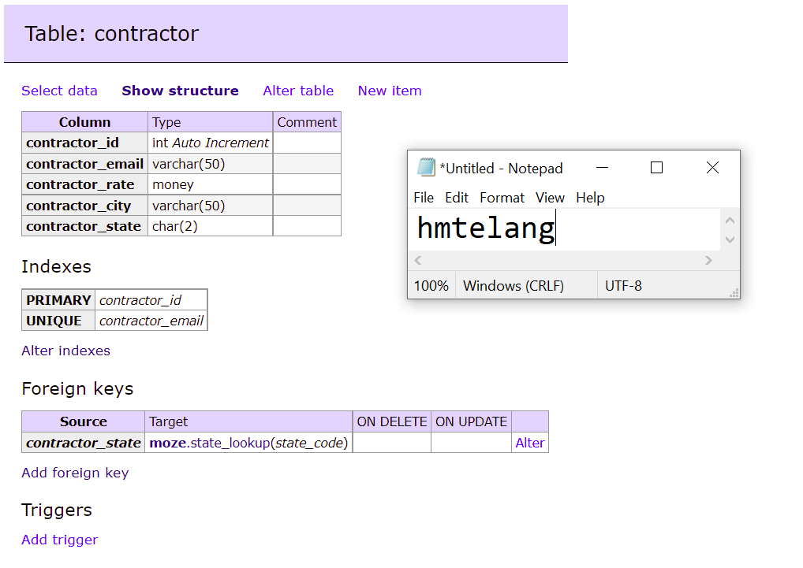
6. Implement the **jobs** table as defined in the overview section. Include columns, indexes (pk/unique) and foreign keys. Provide a screenshot of the table structure screen in Adminer and include the columns, indexes, and foreign keys sections.   
   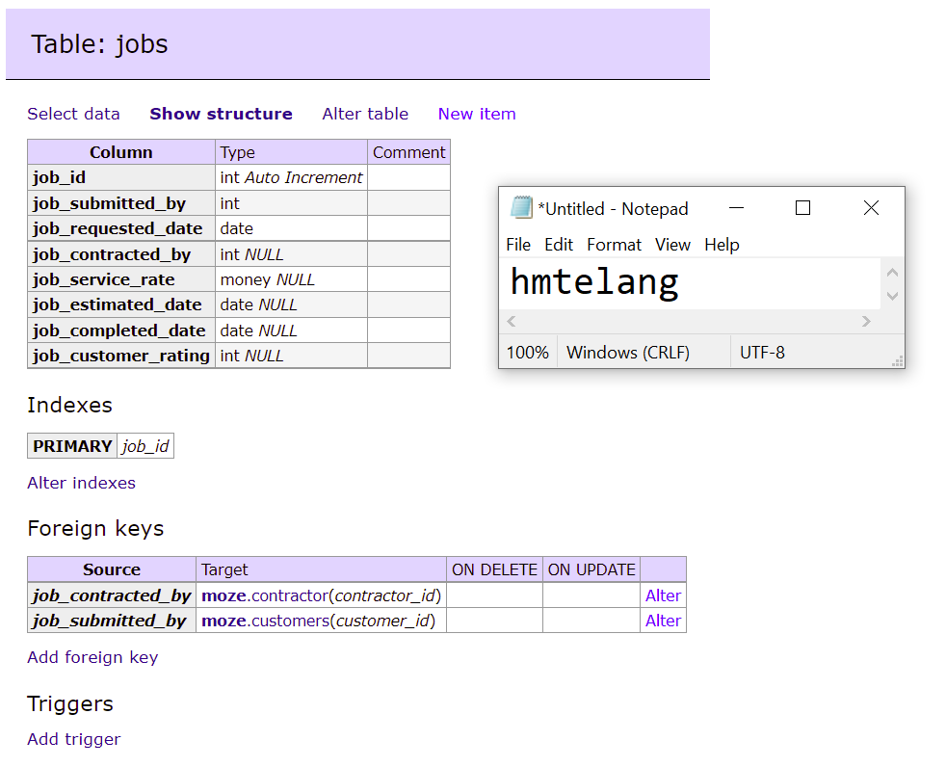
7. Add 3 contractors to the **contractors** table and provide a screenshot of the Select data screen as evidence they were added.  
   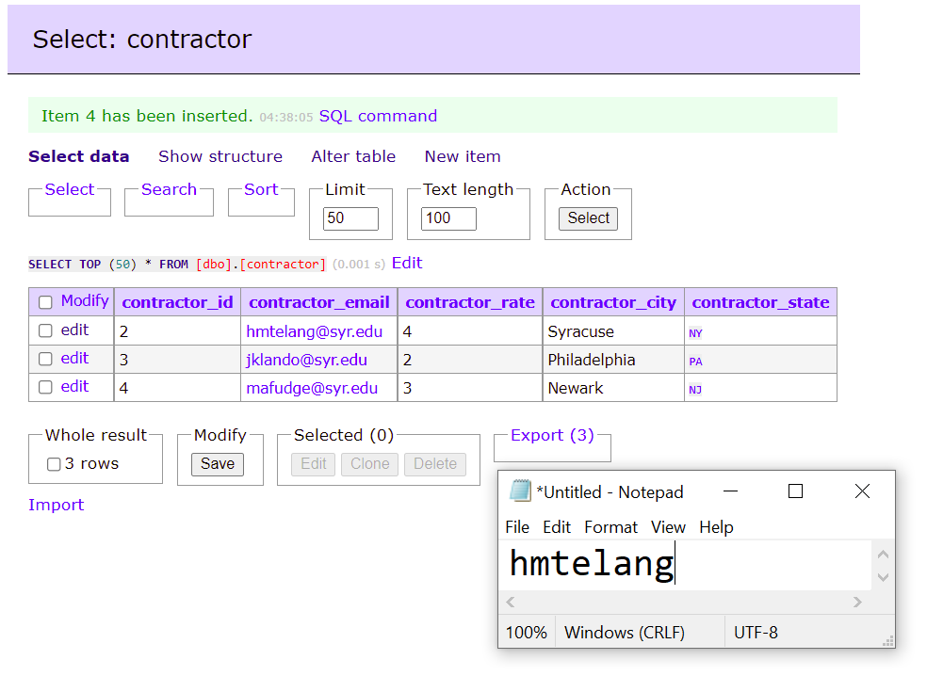
8. Can you add two contractors with the same email address? Explain.  
   **No. It is not possible to add two contractors with the same email address since a unique constraint has already been applied on the metadata ‘contractor_email’ to ensure data integrity in the table.**
9. Can you add a contractor from the state of MA? Explain.  
   **No. We cannot add a contractor from MA because this state does not exist in the lookup table of ‘state_lookup’ thereby violating the referential integrity of the database.**

# Reflection

Use this section to reflect on your learning. To achieve the highest grade on the assignment you must be as descriptive and personal as possible with your reflection.

1. What are the key things you learned through the process of completing this assignment?
2. What were the challenges or roadblocks (if any) you encountered on the way to completing it?
3. Were you prepared for this assignment? What can you do to be better prepared?
4. Now that you have completed the assignment rate your comfort level with this week’s material. This should be an honest assessment: (choose one)  
     
   **4 ==> I understand this material and can explain it to others.**  
   3 ==> I understand this material.  
   2 ==> I somewhat understand the material but sometimes need guidance from others.  
   1 ==> I understand very little of this material and need extra help.